Indiana Jones: Temple of Doom

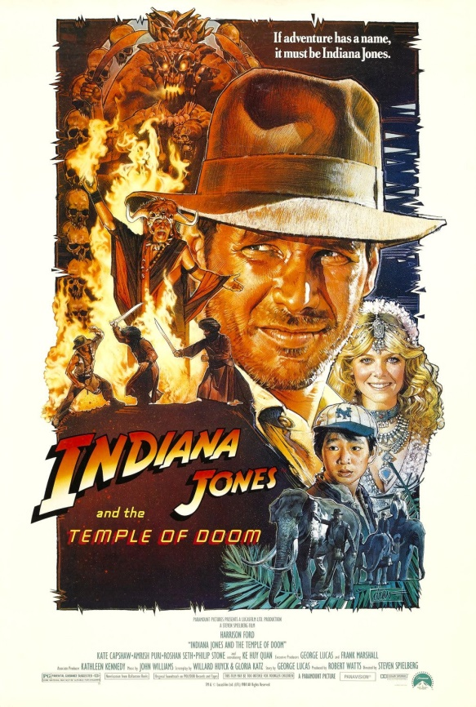

Director: Steven Spielberg

Stars: Harrison Ford, Sean Connery, Alison Doody

Released: 1989

Genre: Adventure

Rating: 8/10

Description: When Dr. Henry Jones Sr. suddenly goes missing while pursuing the Holy Grail, eminent archaeologist Indiana Jones must follow in his father's footsteps and stop the Nazis.

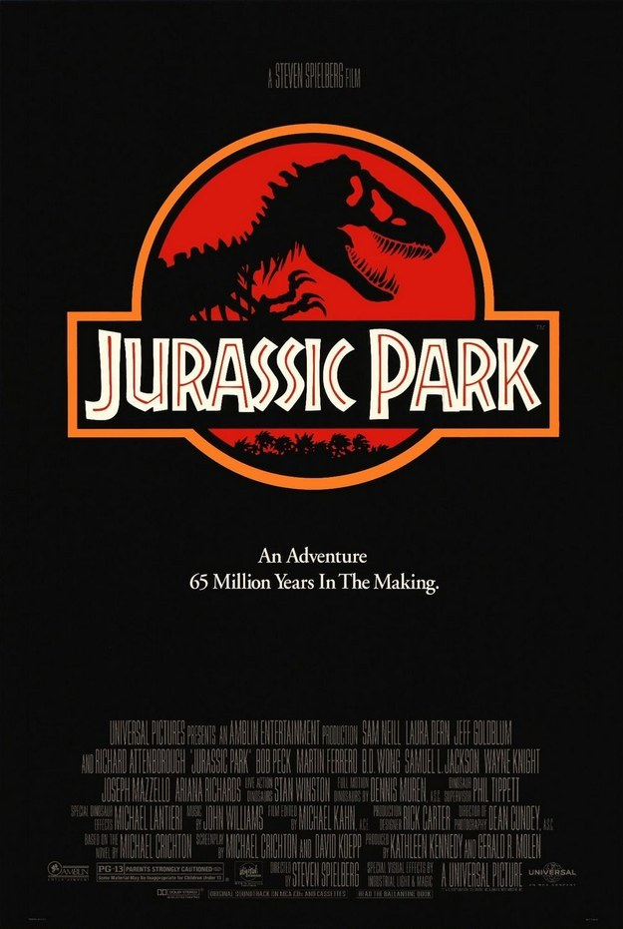Jurassic Park

Director: Steven Spielberg

Stars: Sam Neill, Laura Dern, Jeff Goldblum

Released: 1993

Genre: Adventure

Rating: 8/10

Description: During a preview tour, a theme park suffers a major power breakdown that allows its cloned dinosaur exhibits to run amok.

Lord of the Rings

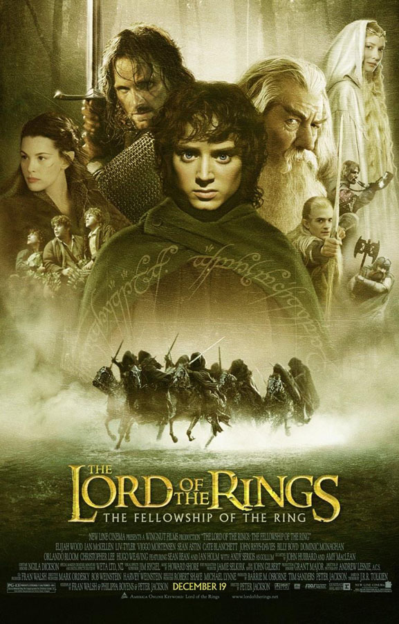

Director: Peter Jackson

Stars: Elijah Wood, Ian McKellen, Orlando Bloom

Released: 2001

Genre: Adventure

Rating: 9/10

Description: A meek hobbit of the Shire and eight companions set out on a journey to Mount Doom to destroy the One Ring and the dark lord Sauron.

Goonies

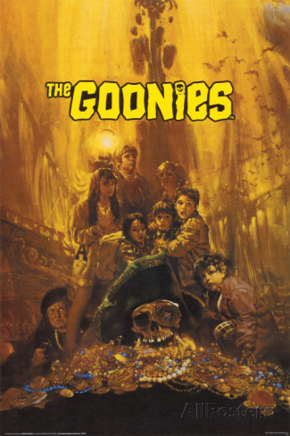

Director: Richard Donner

Stars: Sean Astin, Josh Brolin, Jeff Cohen

Released: 1985

Genre: Adventure

Rating: 8/10

Description: In order to save their home from foreclosure, a group of misfits set out to find a pirate's ancient treasure.

National Treasure

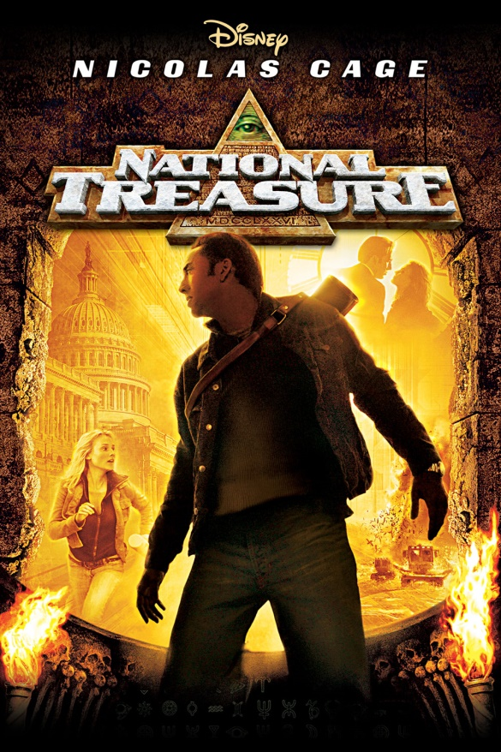

Director: Jon Turteltaub

Stars: Nicolas Cage, Diane Kruger, Justin Bartha

Released: 2004

Genre: Adventure

Rating: 7/10

Description: A historian races to find the legendary Templar Treasure before a team of mercenaries.

27 Dresses



Director: Anne Fletcher

Stars: Katherine Heigl, James Marsden, Malin Akerman

Released: 2008

Genre: Romance

Rating: 6/10

Description: After serving as a bridesmaid 27 times, a young woman wrestles with the idea of standing by her sister's side as her sibling marries the man she's secretly in love with.

The Notebook

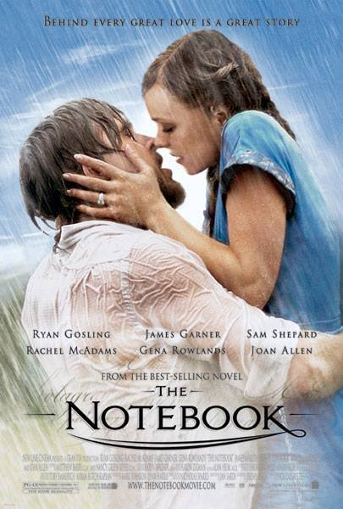

Director: Nick Cassavetes

Stars: Gena Rowlands, James Garner, Rachel McAdams

Released: 2004

Genre: Romance

Rating: 8/10

Description: A poor and passionate young man falls in love with a rich young woman and gives her a sense of freedom. They soon are separated by their social differences.

Dear John

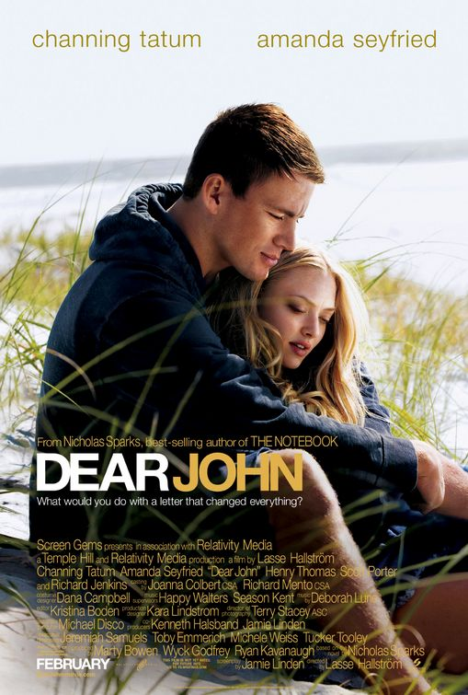

Director: Lasse Hallström

Stars: Channing Tatum, Amanda Seyfried, Richard Jenkins

Released: 2010

Genre: Romance

Rating: 6/10

Description: A romantic drama about a soldier who falls for a conservative college student while he's home on leave.

The Proposal

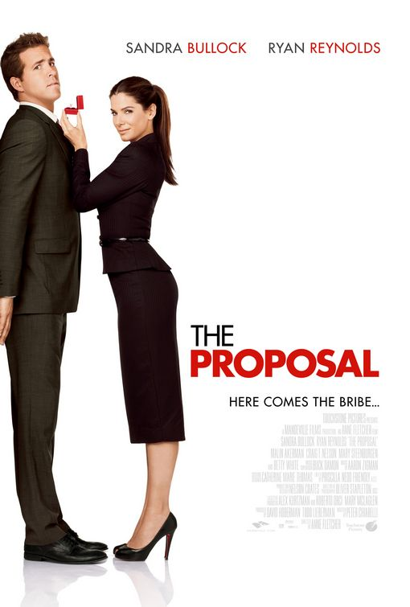

Director: Anne Fletcher

Stars: Sandra Bullock, Ryan Reynolds, Mary Steenburgen

Released: 2009

Genre: Romance

Rating: 7/10

Description: A pushy boss forces her young assistant to marry her in order to keep her Visa status in the U.S. and avoid deportation to Canada.

50 First Dates

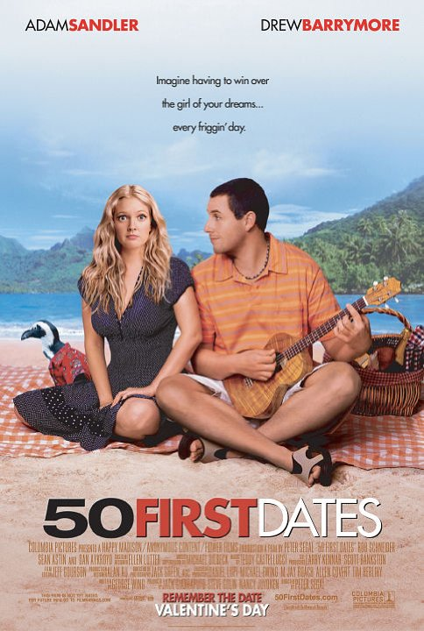

Director: Peter Segal

Stars: Adam Sandler, Drew Barrymore, Rob Schneider

Released: 2004

Genre: Romance

Rating: 7/10

Description: Henry Roth is a man afraid of commitment up until he meets the beautiful Lucy. They hit it off and Henry think he's finally found the girl of his dreams, until he discovers she has short-term memory loss and forgets him the very next day.

Paul Blart: Mall Cop

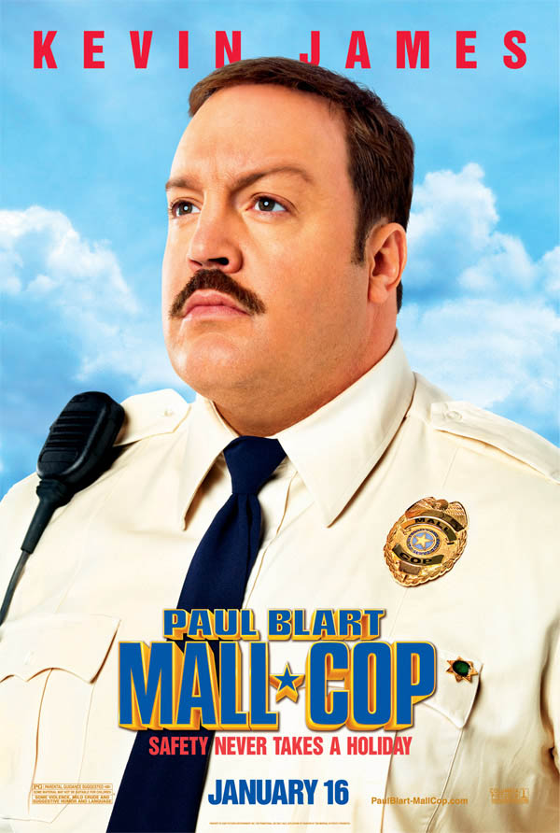

Director: Steve Carr

Stars: Kevin James, Keir O'Donnell, Jayma Mays

Released: 2009

Genre: Comedy

Rating: 5/10

Description: When a shopping mall is taken over by a gang of organized crooks, it's up to a mild-mannered security guard to save the day.

Just Go With It

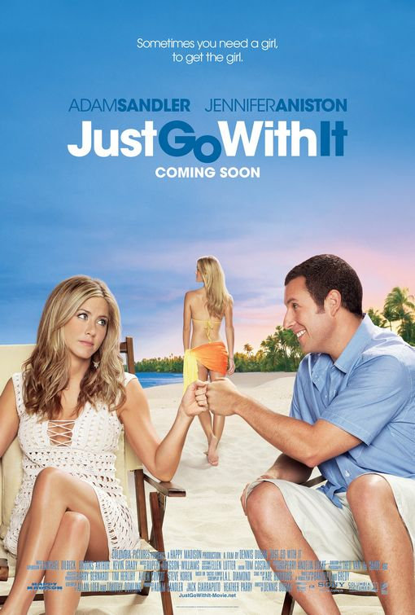

Director: Dennis Dugan

Stars: Adam Sandler, Jennifer Aniston, Brooklyn Decker

Released: 2011

Genre: Comedy

Rating: 6/10

Description: On a weekend trip to Hawaii, a plastic surgeon convinces his loyal assistant to pose as his soon-to-be-divorced wife in order to cover up a careless lie he told to his much-younger girlfriend.

Mrs. Doubtfire

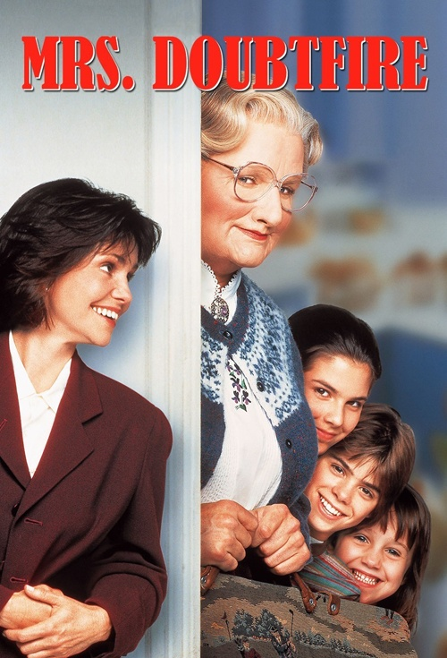

Director: Chris Columbus

Stars: Robin Williams, Sally Field, Pierce Brosnan

Released: 1993

Genre: Comedy

Rating: 7/10

Description: After a bitter divorce, an actor disguises himself as a female housekeeper to spend time with his children held in custody by his former wife.

The Other Guys

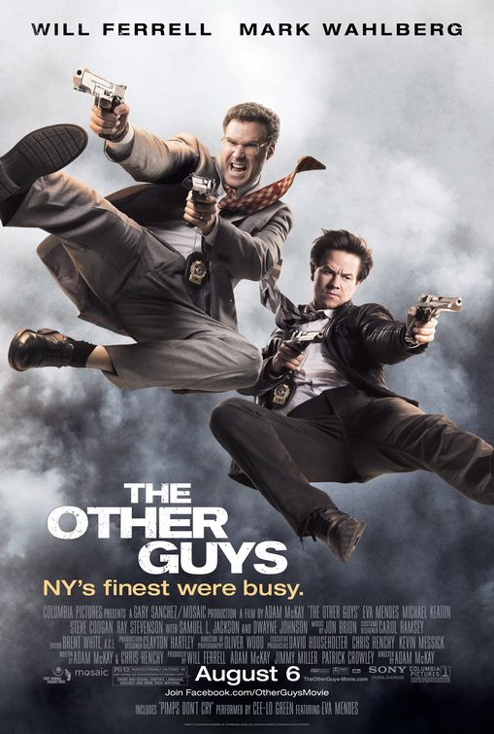

Director: Adam McKay

Stars: Will Ferrell, Mark Wahlberg, Derek Jeter

Released: 2010

Genre: Comedy

Rating: 7/10

Description: Two mismatched New York City detectives seize an opportunity to step up like the city's top cops whom they idolize -- only things don't quite go as planned.

Old School

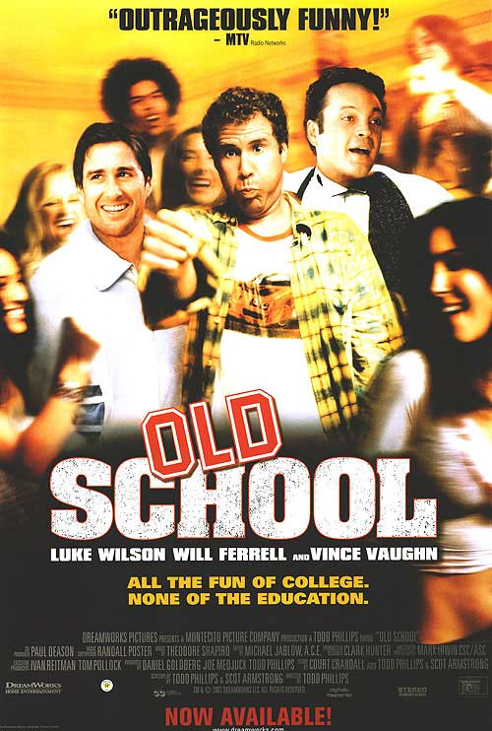

Director: Todd Phillips

Stars: Luke Wilson, Vince Vaughn, Will Ferrell

Released: 2003

Genre: Comedy

Rating: 7/10

Description: Three friends attempt to recapture their glory days by opening up a fraternity near their alma mater.

Alien

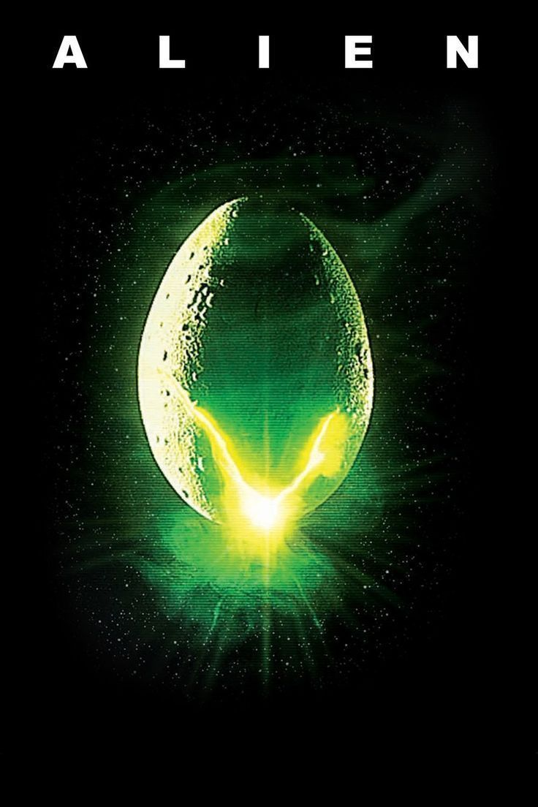

Director: Ridley Scott

Stars: Sigourney Weaver, Tom Skerritt, John Hurt

Released: 1979

Genre: Sci-fi

Rating: 9/10

Description: The commercial vessel Nostromo receives a distress call from an unexplored planet. After searching for survivors, the crew heads home only to realize that a deadly bioform has joined them.

Star Wars VII



Director: JJ Abrams

Stars: John Boyega, Daisy Ridley, Harrison Ford

Released: 2015

Genre: Sci-Fi

Rating: 10/10

Description: As soon as the rebels though the war was over, the remnants of the empire gather together behind a new sith threat. His goal, make the empire powerful once more and finish what Darth Vader started.

Pacific Rim

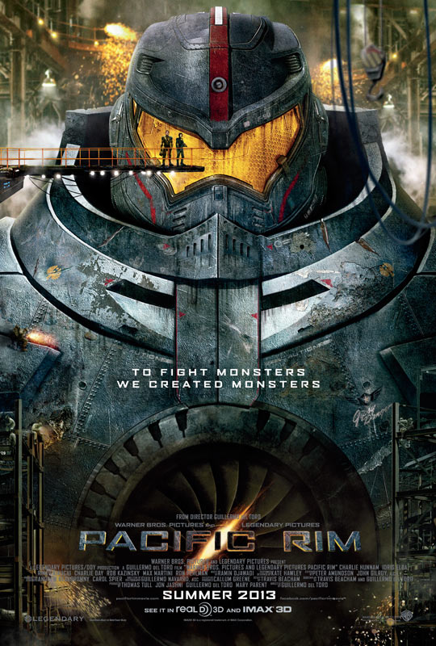

Director: Guillermo del Toro

Stars: Idris Elba, Charlie Hunnam, Rinko Kikuchi

Released: 2013

Genre: Sci-fi

Rating: 7/10

Description: As a war between humankind and monstrous sea creatures wages on, a former pilot and a trainee are paired up to drive a seemingly obsolete special weapon in a desperate effort to save the world from the apocalypse.

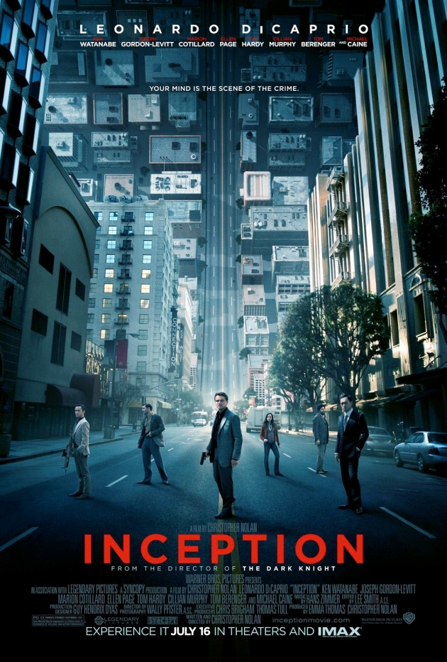Inception

Director: Christopher Nolan

Stars: Leonardo DiCaprio, Joseph Gordon-Levitt, Ellen Page

Released: 2010

Genre: Sci-fi

Rating: 9/10

Description: A thief who steals corporate secrets through use of dream-sharing technology is given the inverse task of planting an idea into the mind of a CEO.

Back to the Future 2

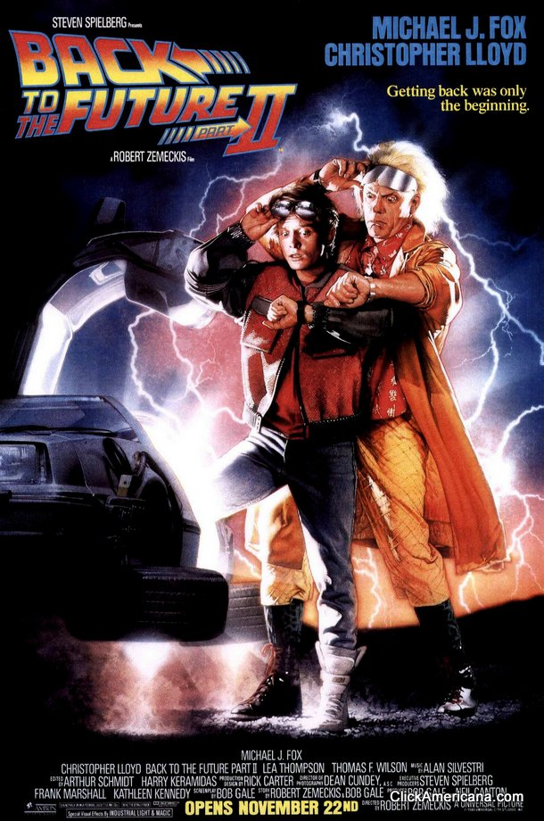

Director: Robert Zemeckis

Stars: Michael J. Fox, Christopher Lloyd, Lea Thompson

Released: 1989

Genre: Sci-fi

Rating: 8/10

Description: After visiting 2015, Marty McFly must repeat his visit to 1955 to prevent disastrous changes to 1985... without interfering with his first trip.

Tangled

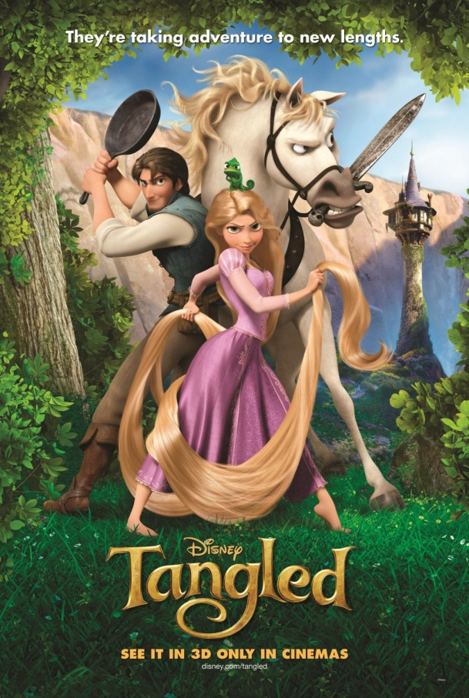

Director: Nathan Greno, Byron Howard

Stars: Mandy Moore, Zachary Levi, Donna Murphy

Released: 2010

Genre: Animated

Rating: 8/10

Description: The magically long-haired Rapunzel has spent her entire life in a tower, but now that a runaway thief has stumbled upon her, she is about to discover the world for the first time, and who she really is.

The Lion King

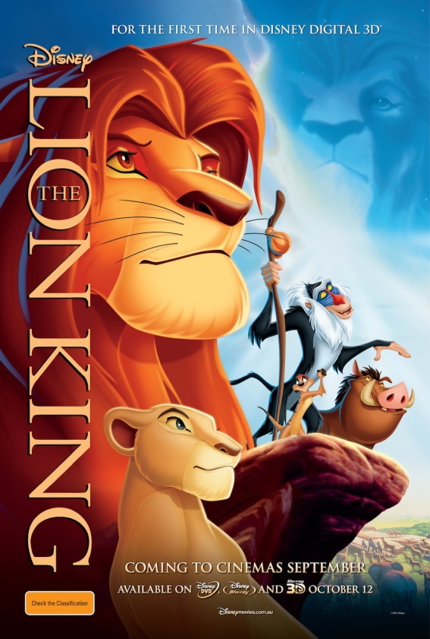

Director: Roger Allers, Rob Minkoff

Stars: Matthew Broderick, Jeremy Irons, James Earl Jones

Released: 1994

Genre: Animated

Rating: 9/10

Description: Lion cub and future king Simba searches for his identity. His eagerness to please others and penchant for testing his boundaries sometimes gets him into trouble.

Lilo and Stitch

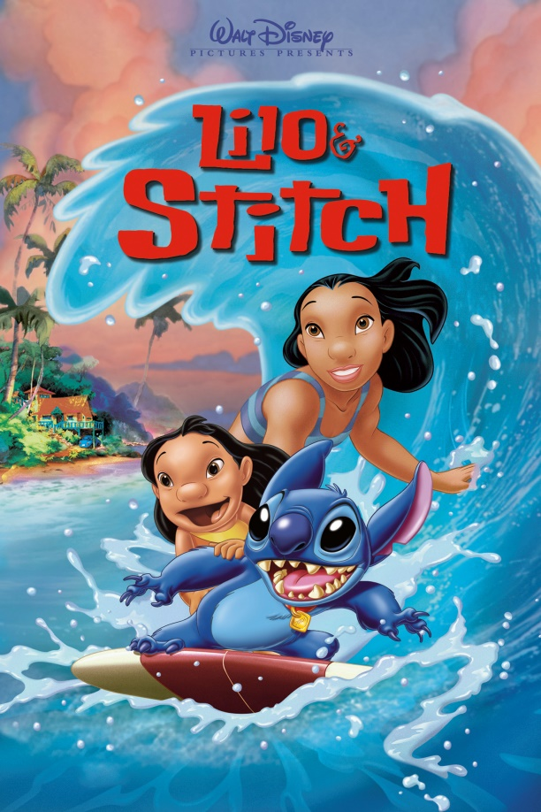

Director: Dean DeBlois, Chris Sanders

Stars: Daveigh Chase, Chris Sanders, Tia Carrere

Released: 2002

Genre: Animated

Rating: 7/10

Description: A Hawaiian girl adopts an unusual pet who is actually a notorious extra-terrestrial fugitive from the law.

Toy story 3

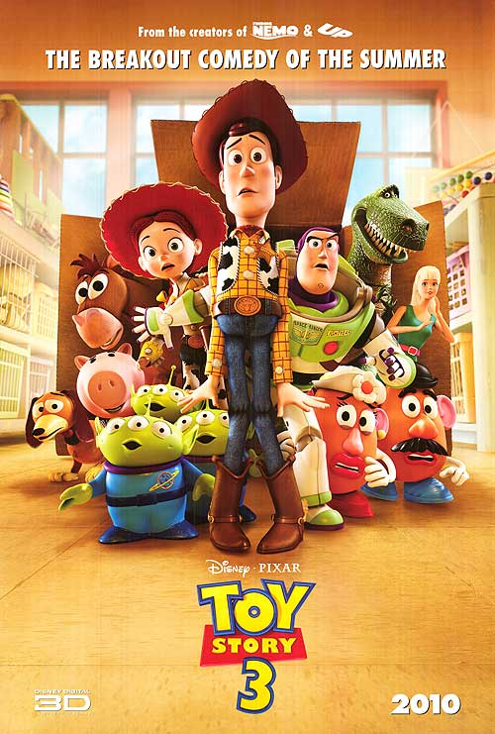

Director: Lee Unkrich

Stars: Tom Hanks, Tim Allen, Joan Cusack

Released: 2010

Genre: Animated

Rating: 8/10

Description: The toys are mistakenly delivered to a day-care center instead of the attic right before Andy leaves for college, and it's up to Woody to convince the other toys that they weren't abandoned and to return home.

Space Jam

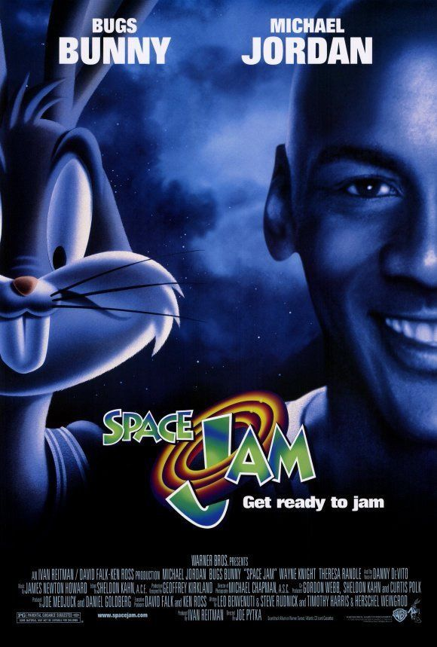

Director: Joe Pytka

Stars: Michael Jordan, Wayne Knight, Theresa Randle

Released: 1996

Genre: Animated

Rating: 6/10

Description: Michael Jordan agrees to help the Looney Toons play a basketball game vs. alien slavers to determine their freedom.

The Karate Kid

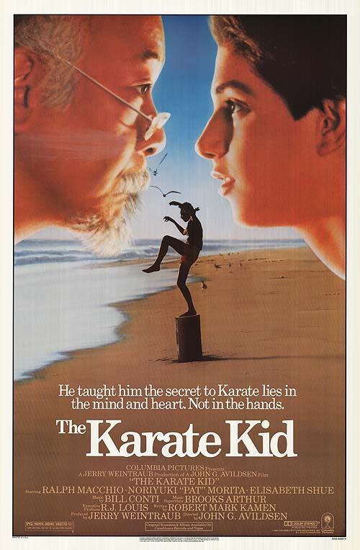

Director: John G. Avildsen

Stars: Ralph Macchio, Pat Morita, Elisabeth Shue

Released: 1984

Genre: Drama

Rating: 7/10

Description: A handyman/martial arts master agrees to teach a bullied boy karate and shows him that there is more to the martial art than fighting.

The Godfather

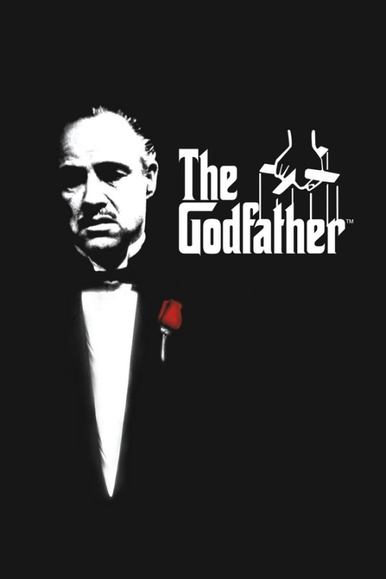

Director: Francis Ford Coppola

Stars: Marlon Brando, Al Pacino, James Caan

Released: 1972

Genre: Drama

Rating: 9/10

Description: The aging patriarch of an organized crime dynasty transfers control of his clandestine empire to his reluctant son.

The Shawshank Redemption

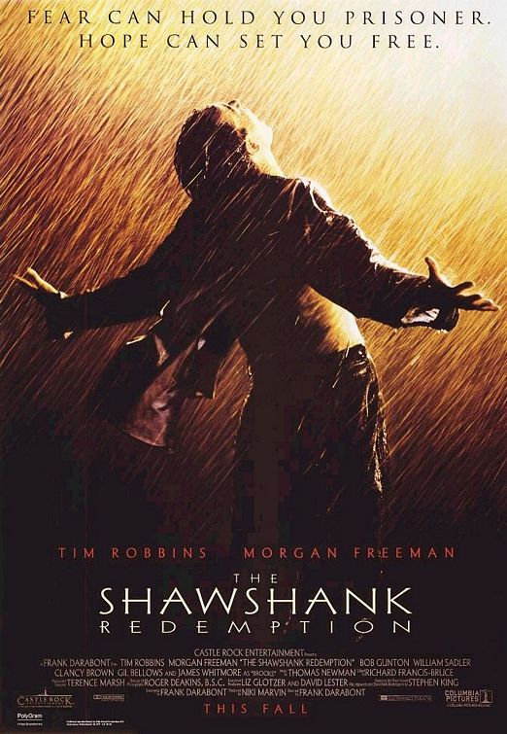

Director: Frank Darabont

Stars: Tim Robbins, Morgan Freeman, Bob Gunton

Released: 1994

Genre: Drama

Rating: 9/10

Description: Two imprisoned men bond over a number of years, finding solace and eventual redemption through acts of common decency.

Forrest Gump

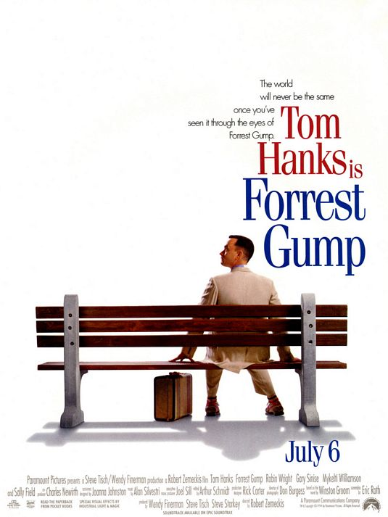

Director: Robert Zemeckis

Stars: Tom Hanks, Robin Wright, Gary Sinise

Released: 1994

Genre: Drama

Rating: 9/10

Description: Forrest Gump, while not intelligent, has accidentally been present at many historic moments, but his true love, Jenny Curran, eludes him.

The Social Network

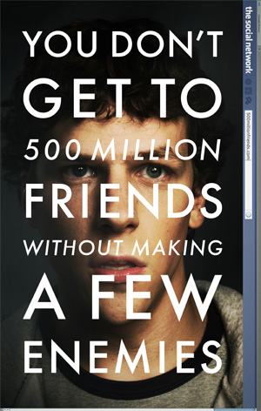

Director: David Fincher

Stars: Jesse Eisenberg, Andrew Garfield, Justin Timberlake

Released: 2010

Genre: Drama

Rating: 8/10

Description: Harvard student Mark Zuckerberg creates the social networking site that would become known as Facebook, but is later sued by two brothers who claimed he stole their idea, and the cofounder who was later squeezed out of the business.

Fight Club

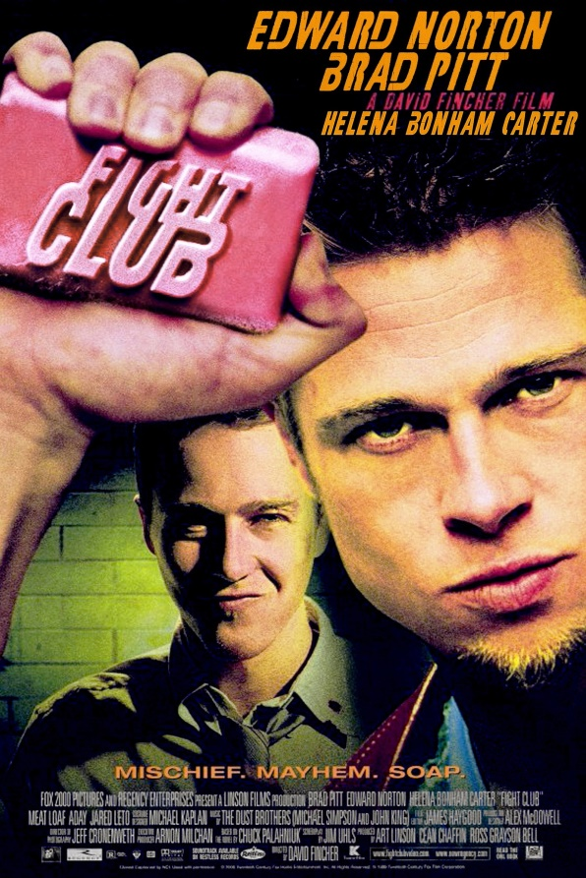

Director: David Fincher

Stars: Brad Pitt, Edward Norton, Helena Bonham Carter

Released: 1999

Genre: Action

Rating: 9/10

Description: An insomniac office worker, looking for a way to change his life, crosses paths with a devil-may-care soap maker, forming an underground fight club that evolves into something much, much more...

Mad Max: Fury Road

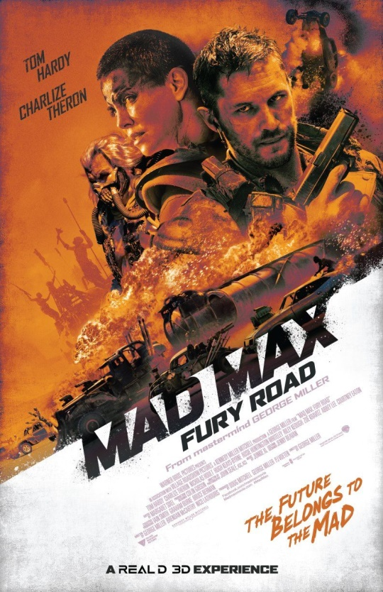

Director: George Miller

Stars: Tom Hardy, Charlize Theron, Nicholas Hoult

Released: 2015

Genre: Action

Rating: 8/10

Description: A woman rebels against a tyrannical ruler in post apocalyptic Australia in search for her homeland with the help of a group of female prisoners, a psychotic worshiper, and a drifter named Max.

Terminator 2: Judgement Day

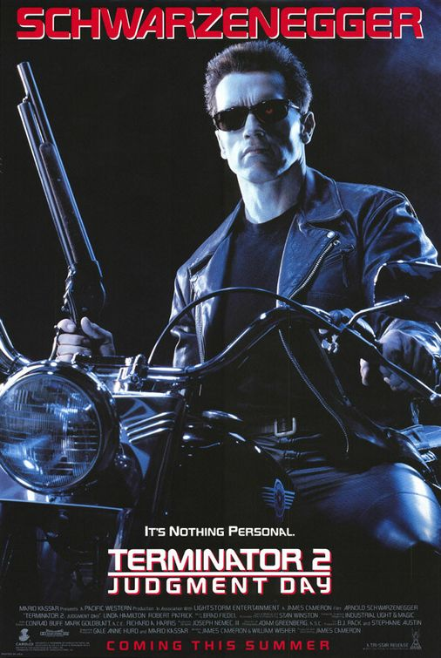

Director: James Cameron

Stars: Arnold Schwarzenegger, Linda Hamilton, Edward

Released: 1991

Genre: Action

Rating: 9/10

Description: A cyborg, identical to the one who failed to kill Sarah Connor, must now protect her young son, John Connor, from a more advanced cyborg, made out of liquid metal.

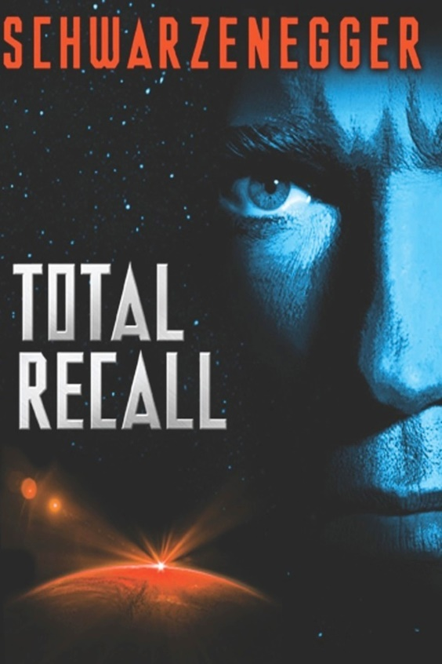Total Recall

Director: Paul Verhoeven

Stars: Arnold Schwarzenegger, Sharon Stone, Michael Ironside

Released: 1990

Genre: Action

Rating: 8/10

Description: When a man goes for virtual vacation memories of the planet Mars, an unexpected and harrowing series of events forces him to go to the planet for real, or does he?

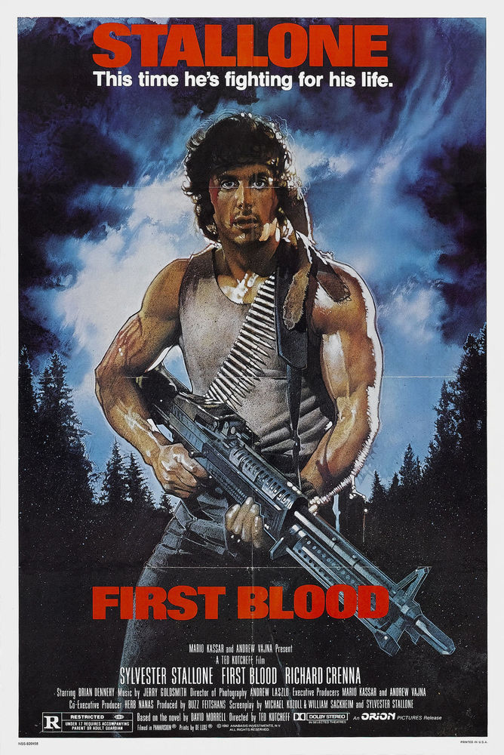First Blood

Director: Ted Kotcheff

Stars: Sylvester Stallone, Brian Dennehy, Richard Crenna

Released: 1982

Genre: Action

Rating: 8/10

Description: A Vietnam Veteran uses his combat skills against the lawman of a small town when they arrest and abuse him.